**Experiment 2.2**

**Student Name:   Gaurav Kumar                                UID: 22MCC20177**

**Branch:   CC-DevOps                                                        Section/Group: 1/B**

**Semester:   I                                                               Date of Performance: 21/12/2022**

**Subject Name:** **Linux Administration Lab Subject Code: 22CAP-648**

1. **Aim/Overview of the practical:**

* **Create a file test file having 5 students names now display first two names and last one name in file. Then display first 3 and last 4 characters of file. count the number of lines and characters in file individually and display content along with no of lines then sort the names in reverse dictionary order and save in file name as student_list and in end display content of student list in upper case alphabets**

1. **Steps**

* To create a file with the names of 5 students, you can use a text editor such as **nano or vi:**
  + Open a **terminal** and navigate to the directory where you want to create the file.
  + Type **nano** **test_file.txt** and press Enter. This will open the **nano** text editor.
  + Type the names of the 5 students, each on a new line.
  + To save the file, press **Ctrl + O** and then press Enter.
  + To exit the **nano** text editor, press **Ctrl + X**.
* To display the first two names and the last name in the file, you can use the **head and tail** commands:
  + In the terminal, type **head -n 2 student.txt && tail -n 1 student.txt**



* To display the **first 3 and last 4 characters** of the file, you can use the **cut** **and grep** command:
  + In the terminal, type **cut -c 1-3 student.txt && grep -o ".\{4\}$" <student.txt** and press Enter. This will display the first 3 characters and last 4 character of each line in the file.

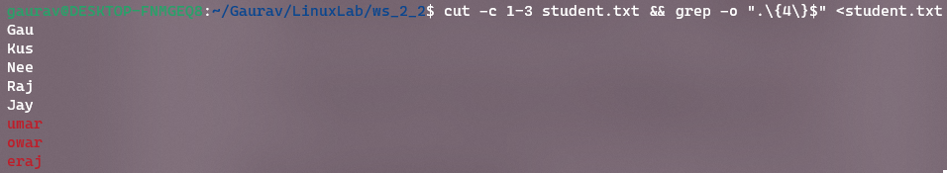

* To count the number of lines and characters in the file individually, you can use the **wc** command:
  + To count the number of lines in the file, type **wc -l student.txt && wc -c student.txt** and press Enter.



* To sort the names in the file in reverse dictionary order and save the sorted list in a new file called student_list, you can use the **sort** command:
  + In the terminal, type **sort -r student.txt > student_list.txt** and press Enter. This will sort the names in the test_file.txt file in reverse dictionary order and save the sorted list in a new file called student_list.txt.
* To display the content of the **student_list.txt** file in uppercase letters, you can use the **tr** command:
* In the terminal, type **tr [:lower:] [:upper:] < student_list.txt** and press Enter. This will convert all lowercase letters in the **student_list.txt** file to uppercase letters and display the result in the terminal.

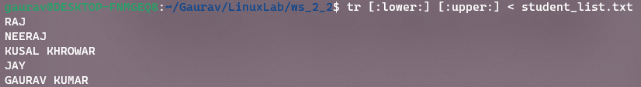

1. 2. Write fdisk –l to view the partitions
2. 3. Select the partition using fdisk /dev/sda1
3. 4. Disk Partitions displayed with details
4. We can also view Disk partitions using lsblk. it displays block devices, when used with the -f option, it
5. prints file system type on partitions as well
6. now Creating primary partition and 2 extended partitions
7. **Learning outcomes (What I have learnt):** 
   * 1. **Learn about cut.**
     2. **Learn about cat and grep.**
     3. **Learn about tr.**

**Evaluation Grid:**

|  |  |  |  |
| --- | --- | --- | --- |
| Sr. No. | Parameters | Marks Obtained | Maximum Marks |
| 1. | Demonstration and Performance  (Quiz) |  | 22 |
| 2. | Worksheet |  | 8 |